Backend API for Customer Management System This project is a backend API for a Customer Management System, developed using Spring Boot and MySQL database. It provides full functionality for managing customers, including authentication, CRUD operations, data synchronization, and search functionality.

Features Authentication: Users can log in using a username and password. JWT is used for authorization. CRUD Operations: Users can view, add, edit, and delete customer records. Data Synchronization: Users can sync customer data by clicking the sync button. Search Functionality: Customers can be searched by various parameters including first name, last name, phone number, email address, city, address, and street. Swagger API: Swagger API documentation is included for easy API reference. Technologies Used Spring Boot: Backend framework for building Java applications. MySQL Database: Database management system for storing customer data. JWT (JSON Web Tokens): Used for authentication and authorization. Swagger API: Dependency included for API documentation. HTML, CSS, JS: Used for creating frontend pages (frontend work in progress).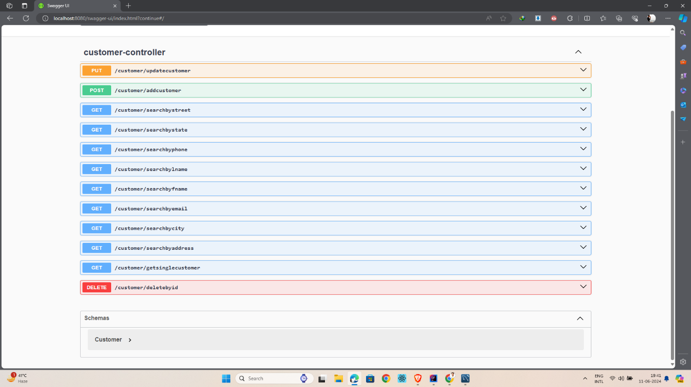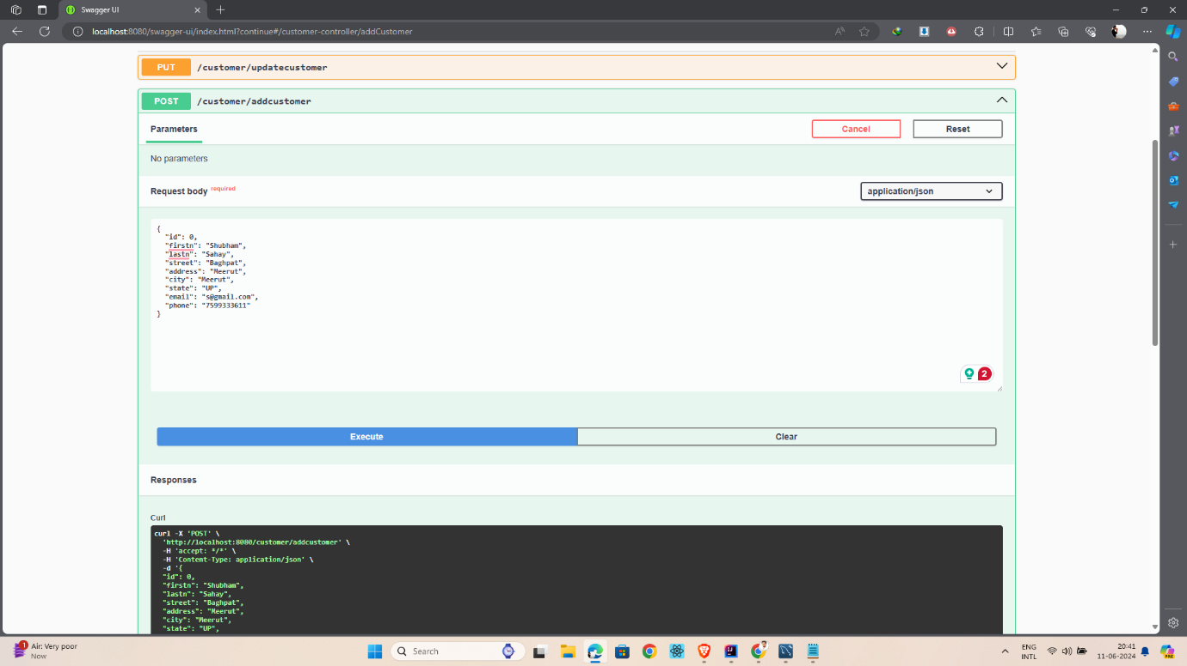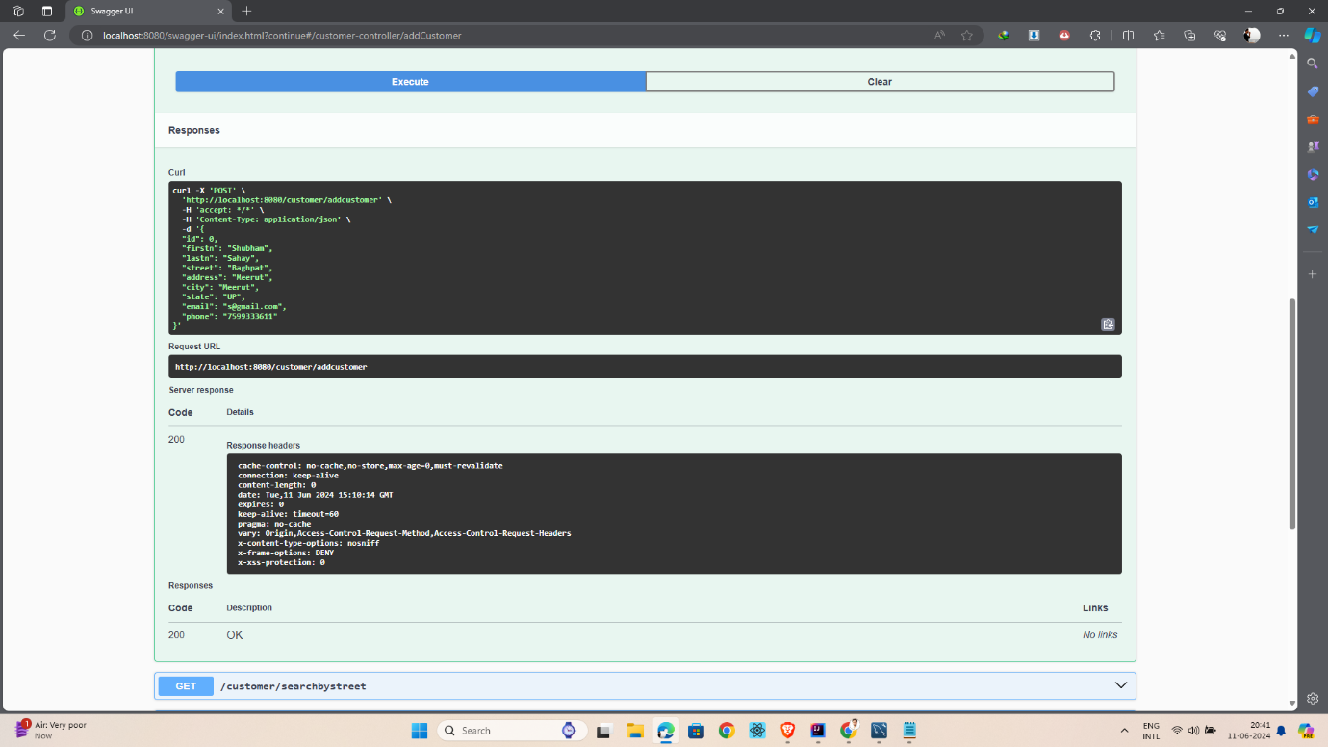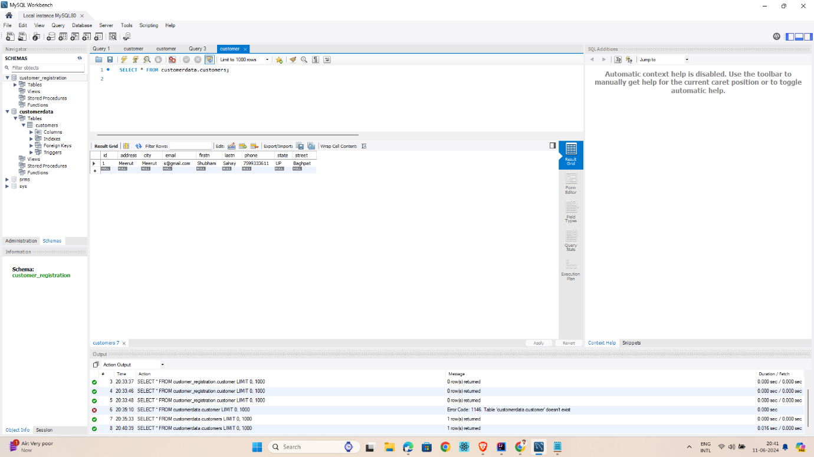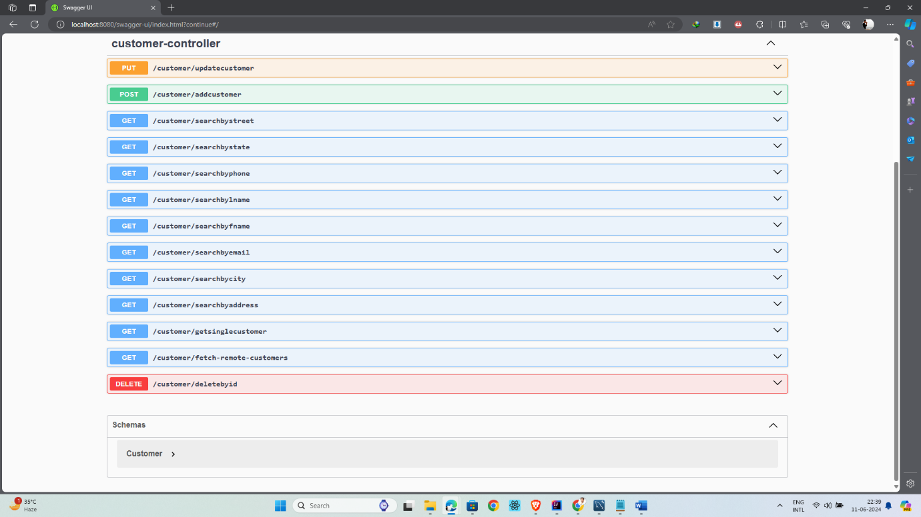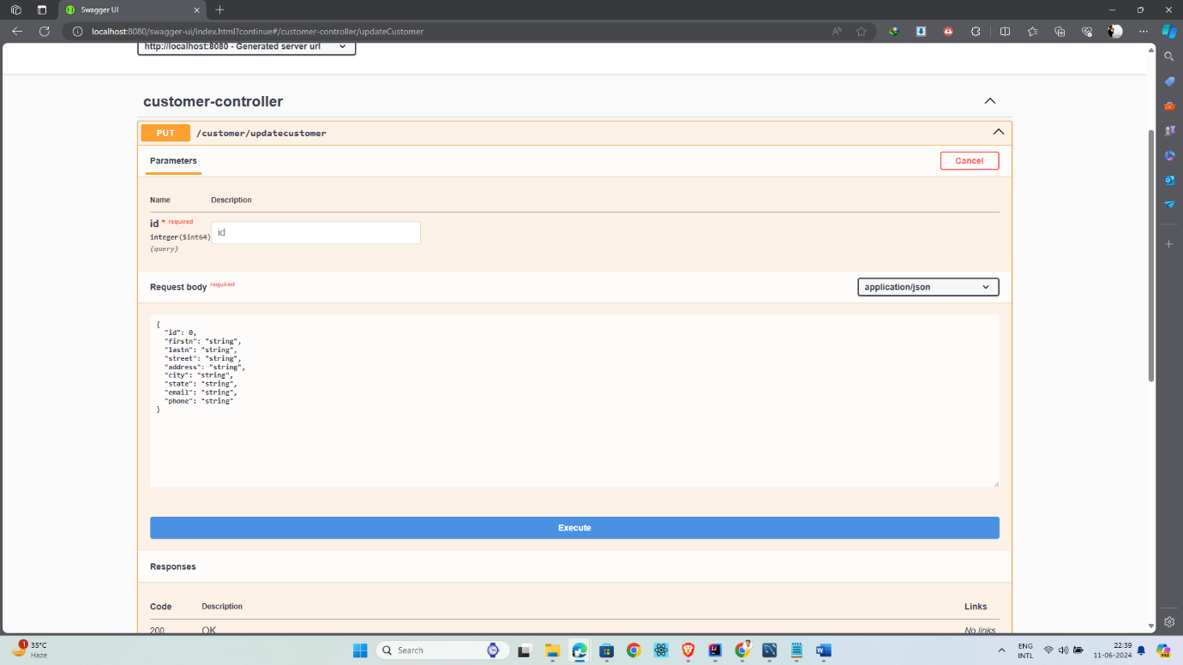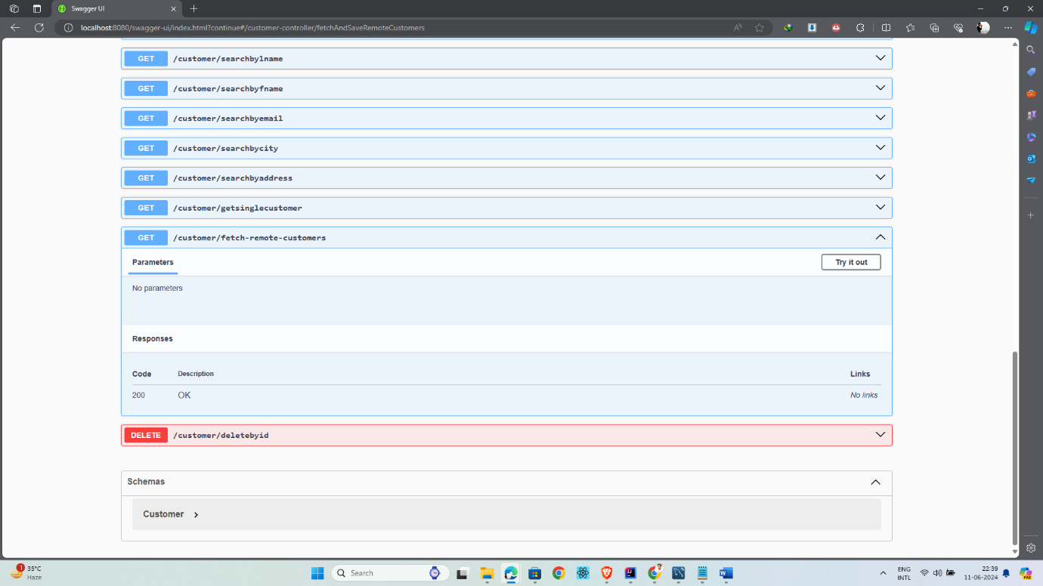

Frontend (Work in Progress) Frontend pages have been created using HTML, CSS, and JavaScript. However, frontend integration with the backend is pending. Frontend work is ongoing and will be merged with the backend soon.

